1. **Database Normalization Evaluation**

The created database is in 3NF, as I have evaluated every table in my database and determined that each table has a primary key and there is not any tables of any repeating attributes or repeating loops. Also, there’s no table containing partial or transitive dependencies.

1NF: All tables are in 1NF as all attributes of each table are single valued. For example, for Customer table, if we have a customer that has multiple phone numbers, we are going to have two separate rows for that same customer, having the same information except for the T_CustomerPhoneNumber_CU column, it will have different value for each phone number.

2NF: Since a partial dependency can exist only if a table's primary key is composed of several attributes and since all tables are in 1NF (as proved above) and have a single-attribute primary key (except for EmployeeSkill, ProjectSchedule, TaskSkill tables), then all tables are automatically in 2NF. EmployeeSkill, ProjectSchedule, TaskSkill are also still in 2NF because all of their non key attributes are fully functionally dependent on the primary key. So for ProjectSchedule table, D_TaskStartDate_PS and D_TaskEndDate_PS attributes are fully dependent on both C_ProjectID_PS and C_TaskID_PS primary keys not just on one of them. Similarly, for TaskSkill table, I_QuantityRequired_TS attributes are fully dependent on on both C_SkillID_TS and C_TaskID_TS primary keys. Lastly, for EmployeeSkill table, since it doesn’t have any non-primary attributes and all it has just C_EmployeeID_ES and C_SkillID_ES primary keys columns, it’s automatically in 2NF.

3NF: There is not any table containing transitive dependencies.

1. **SQL DDL**

*--Region*

**CREATE** **TABLE** Region

(

C_RegionID_RG INT **PRIMARY** **KEY**,

T_RegionName_RG VARCHAR(50) **NOT** **NULL**,

T_RegionCode_RG VARCHAR(2) **NOT** **NULL**

);

*--Employee*

**CREATE** **TABLE** Employee

(

C_EmployeeID_EP INT **PRIMARY** **KEY**,

T_LastName_EP VARCHAR(50) **NOT** **NULL**,

T_MiddleInitial_EP VARCHAR(2),

T_FirstName_EP VARCHAR(50) **NOT** **NULL**,

D_HireDate_EP DATETIME **NOT** **NULL**,

C_RegionID_EP INT **NOT** **NULL** **CONSTRAINT** FK_RegionID_EP **REFERENCES** Region(C_RegionID_RG)

);

*--Skill*

**CREATE** **TABLE** Skill

(

C_SkillID_SK INT **PRIMARY** **KEY**,

T_SkillDescription_SK VARCHAR(100) **NOT** **NULL**,

N_PayRate_SK NUMBER **NOT** **NULL**

);

*--EmployeeSkill*

**CREATE** **TABLE** EmployeeSkill

(

C_EmployeeID_ES INT **NOT** **NULL** **CONSTRAINT** FK_EmployeeID_ES **REFERENCES** Employee(C_EmployeeID_EP),

C_SkillID_ES INT **NOT** **NULL** **CONSTRAINT** FK_SkillID_ES **REFERENCES** Skill(C_SkillID_SK),

**PRIMARY** **KEY**(C_EmployeeID_ES, C_SkillID_ES)

);

*--Customer*

**CREATE** **TABLE** Customer

(

C_CustomerID_CU INT **PRIMARY** **KEY**,

T_CustomerName_CU VARCHAR(200) **NOT** **NULL**,

T_CustomerPhoneNumber_CU VARCHAR(50) **NOT** **NULL**,

C_RegionID_CU INT **NOT** **NULL** **CONSTRAINT** FK_RegionID_CU **REFERENCES** Region(C_RegionID_RG)

);

*--Project*

**CREATE** **TABLE** Project

(

C_ProjectID_PJ INT **PRIMARY** **KEY**,

T_ProjectDescription_PJ VARCHAR(255) **NOT** **NULL**,

D_ProjectContractDate_PJ DATETIME,

D_ProjectEstimatedStartDate_PJ DATETIME,

D_ProjectEstimatedEndDate_PJ DATETIME,

N_ProjectEstimatedBudget_PJ NUMBER,

D_ProjectActualStartDate_PJ DATETIME,

D_ProjectActualEndDate_PJ DATETIME,

N_ProjectActualCost_PJ NUMBER,

C_CustomerID_PJ INT **NOT** **NULL** **CONSTRAINT** FK_CustomerID_PJ **REFERENCES** Customer(C_CustomerID_CU),

C_EmployeeID_PJ INT **NOT** **NULL** **CONSTRAINT** FK_EmployeeID_PJ **REFERENCES** Employee(C_EmployeeID_EP)

);

*--Task*

**CREATE** **TABLE** Task

(

C_TaskID_TK INT **PRIMARY** **KEY**,

T_TaskDescription_TK VARCHAR(255) **NOT** **NULL**

);

*--Project Schedule*

**CREATE** **TABLE** ProjectSchedule

(

C_ProjectID_PS INT **NOT** **NULL** **CONSTRAINT** FK_ProjectID_PS **REFERENCES** Project(C_ProjectID_PJ),

C_TaskID_PS INT **NOT** **NULL** **CONSTRAINT** FK_TaskID_PS **REFERENCES** Task(C_TaskID_TK),

D_TaskStartDate_PS DATETIME,

D_TaskEndDate_PS DATETIME,

**PRIMARY** **KEY**(C_ProjectID_PS, C_TaskID_PS)

);

*--TaskSkill*

**CREATE** **TABLE** TaskSkill

(

C_SkillID_TS INT **NOT** **NULL** **CONSTRAINT** FK_SkillID_TS **REFERENCES** Skill(C_SkillID_SK),

C_TaskID_TS INT **NOT** **NULL** **CONSTRAINT** FK_TaskID_TS **REFERENCES** Task(C_TaskID_TK),

I_QuantityRequired_TS INT **NOT** **NULL**,

**PRIMARY** **KEY**(C_SkillID_TS, C_TaskID_TS)

);

*--Assignment*

**CREATE** **TABLE** **Assignment**

(

C_AssignmentID_AS INT **PRIMARY** **KEY**,

C_EmployeeID_AS INT **NOT** **NULL** **CONSTRAINT** FK_EmployeeID_AS **REFERENCES** Employee(C_EmployeeID_EP),

C_TaskID_AS INT **NOT** **NULL** **CONSTRAINT** FK_TaskID_AS **REFERENCES** Task(C_TaskID_TK),

D_AssignmentStartDate_AS DATETIME,

D_AssignmentEndDate_AS DATETIME

);

*--Bill*

**CREATE** **TABLE** Bill

(

C_BillID_BL INT **PRIMARY** **KEY**,

N_TotalHoursWorked_BL NUMBER,

D_PeriodStartDate_BL DATETIME,

D_PeriodEndDate_BL DATETIME

);

*--Work Log*

**CREATE** **TABLE** WorkLog

(

C_WorkLogID_WL INT **PRIMARY** **KEY**,

N_HoursWorked_WL NUMBER,

D_WeekEndingDate_WL DATETIME,

C_AssignmentID_WL INT **NOT** **NULL** **CONSTRAINT** FK_AssignmentID_WL **REFERENCES** **Assignment**(C_AssignmentID_AS),

C_BillID_WL INT **NOT** **NULL** **CONSTRAINT** FK_BillID_WL **REFERENCES** Bill(C_BillID_BL)

);

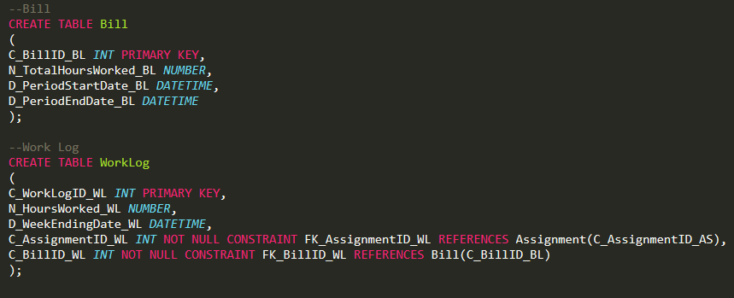

1. **Screenshots of the Database in Access DBMS**

